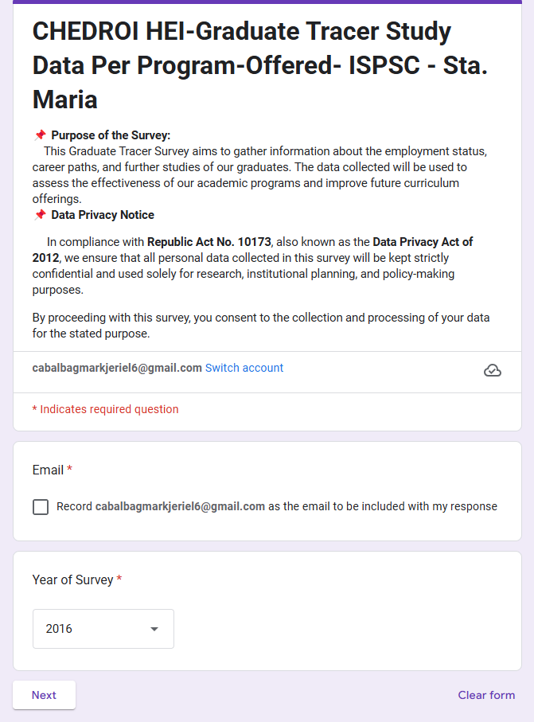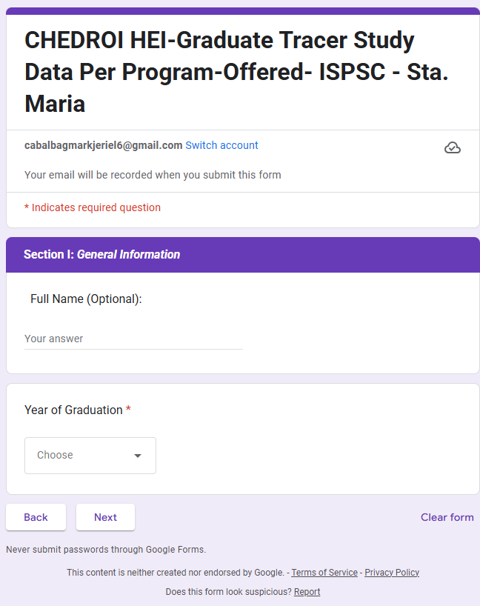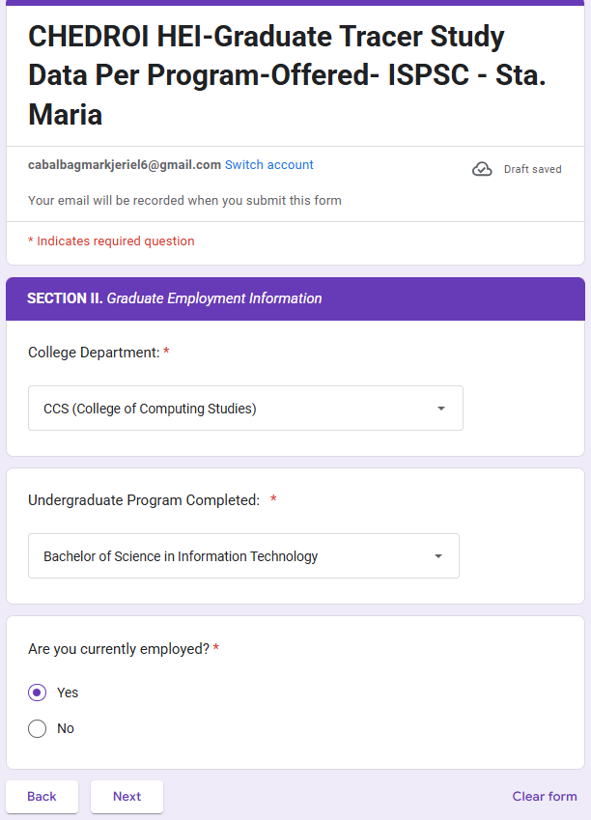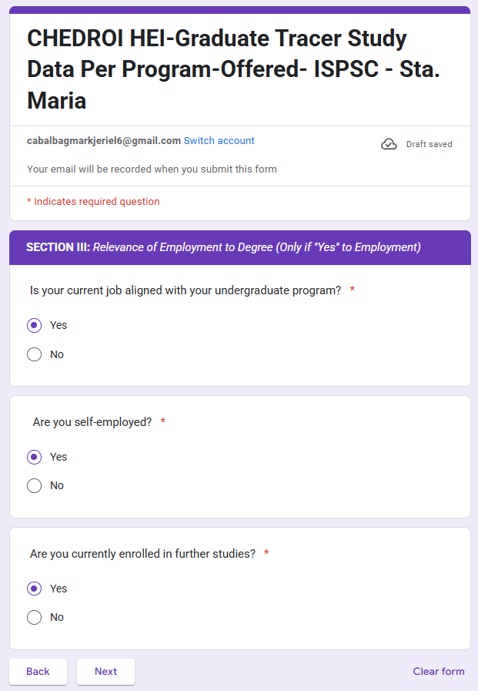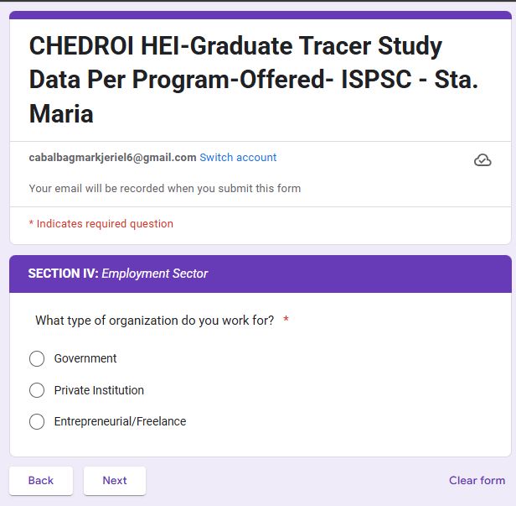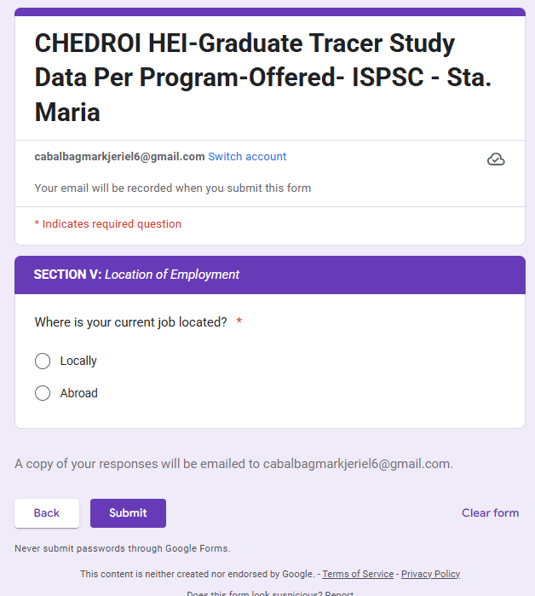

PROJECT TITLE: GRADUATE TRACER FOR ISPSC STA. MARIA

DATE: 2-28-25

***REQUIREMENTS***

USER – *(STUDENT)*

* *Fill out form related to the ched requirements.*
* *Can review the reponses before submitting the form*
* *Can receive confirmation about the form through email*

ADMIN – *(MIS OFFICE)*

* Can filter the results base on the year graduated
* Can filter out the list of responses base on the department and year graduation
* Can remove or edit student information
* Can share the dashboard view
* Can export the results into pdf and excel

*\*\*ADDITIONAL FEATURE FOR ADMIN\*\**

* *(CRUD)Can add, edit, delete:*

*PROGRAMS*

*DEPARTMENTS*

*MAJORS*

**ADVANCEMENT OF THE DEVELOPMENT**

* **Can dynamically add Departments**
* **Can dynamically add courses related to the department**
* **Can dynamically remove courses related to the major**
* **Can dynamically edit courses related to the department**

TOOLS

***FRONTEND***

* ReactJS (Typescript)

***BACKEND***

* NodeJs

***DATABASE***

* SQL

**DATA MODELING**

USER

* *Id*
* *yearOfSurvey*
* *fullName*
* *yearOfGraduation*
* *collegeDepartment*
* *underGraduateProgram*
* *graduateProgram*
* *currentlyEmployed*
* *isJobAligned*
* *isSelfEmployed*
* *isFurtherStudies*
* *typeOfOrganization*
* *currentJobLocated*

DEPARTMENT

* id
* department
* listOfPrograms[]

PROGRAMS

* id
* program
* listOfMajor[]
* departmentId
* type (undergraduate, graduate)

MAJOR

* id
* major
* programId